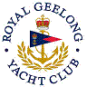 | Royal Geelong Yacht Club Inc.  Est 1859
Trophy Deed of Gift.

Trophy: | Geelong Advertiser Trophy
Presented by: | Geelong Advertiser
Date: | Circa 1946
For: | I.Y.R.U. Rated Classes: January Regatta
Remarks / Revisions | 1967-1968: Changed to RORC Rating  Trophy decided over two events  - Williamstown – Geelong (“Passage Race”), and  - an Olympic Course race Sunday Afternoon  - Each Club to be represented by two boats that comply with RORC requirements  : Changed to IOR
Click here for a List of Recipients

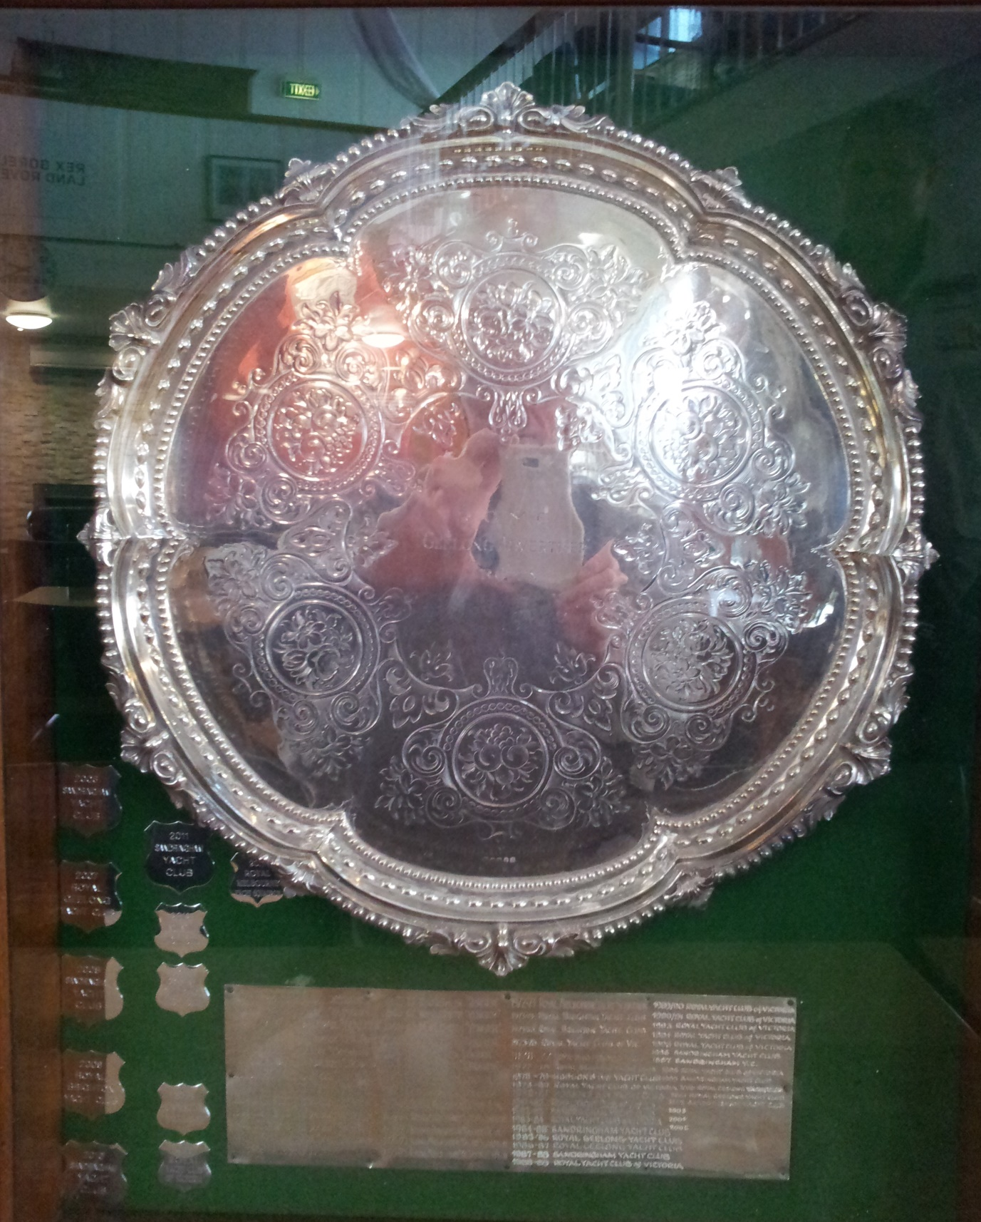

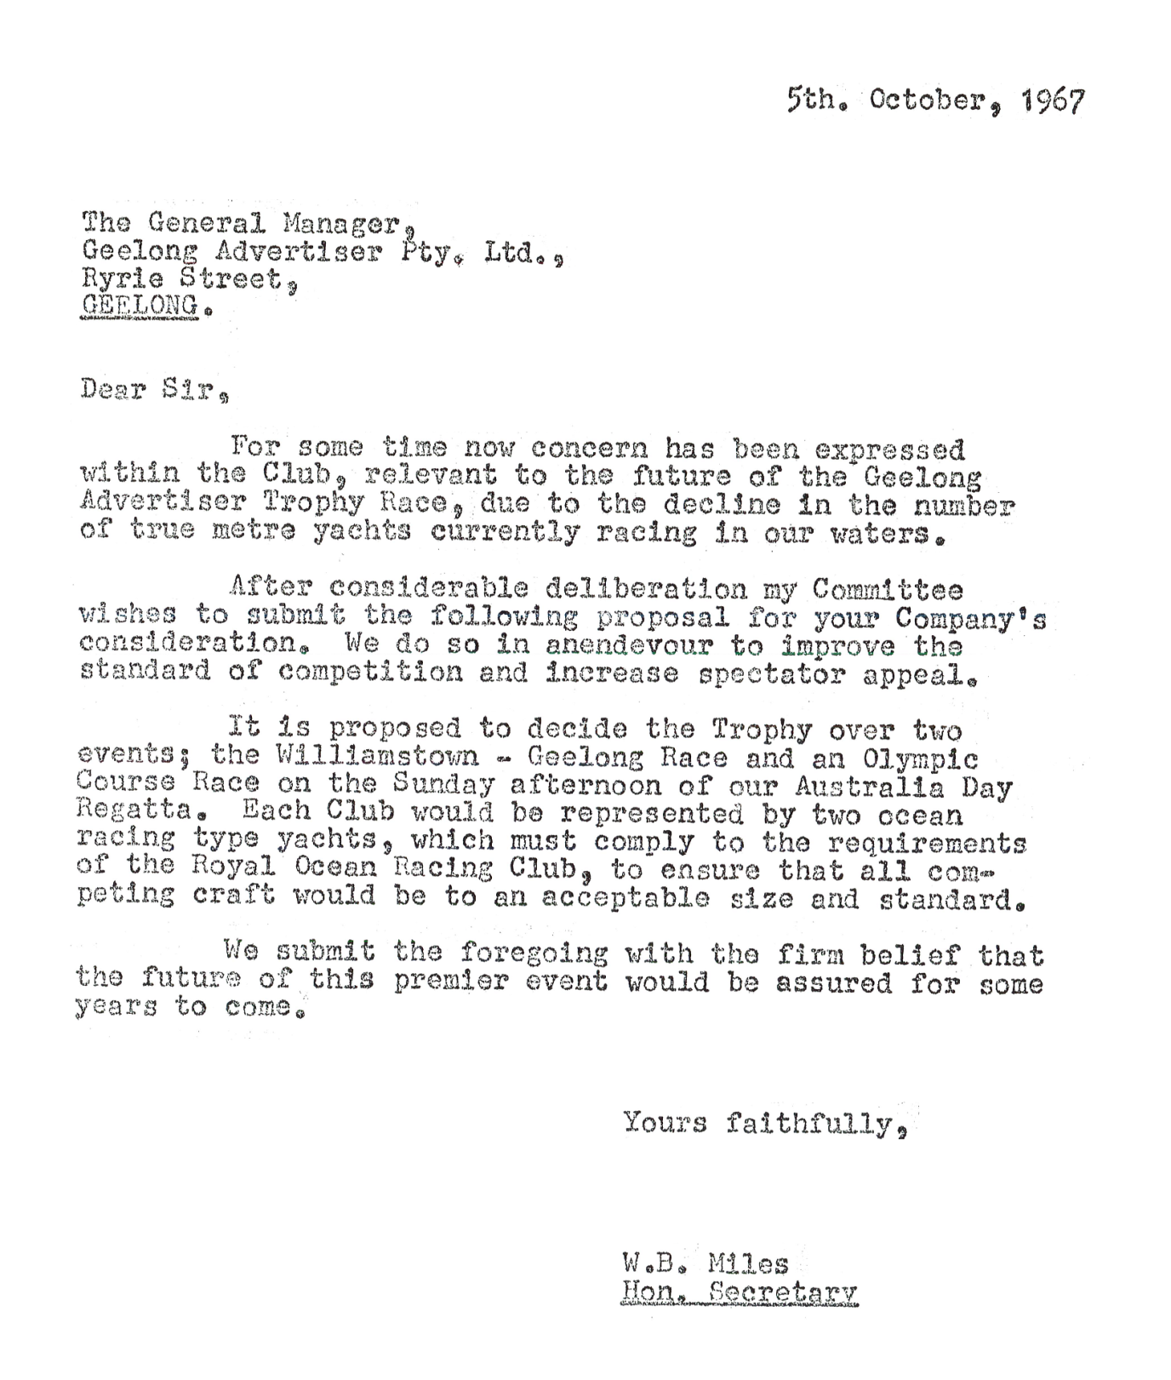

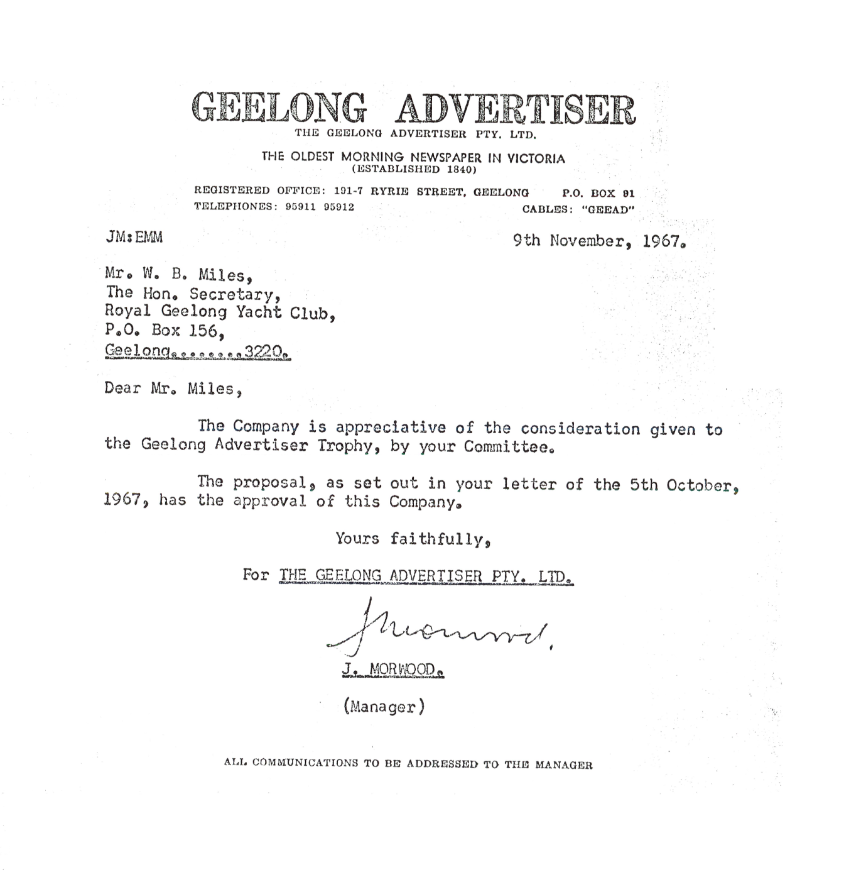

Editor’s Note:
For many years, this was the premier event of the January Regatta. Traditionally its was for Meter-Rated boats only, with racing on Sunday Afternoon… Winner Take All.
The sister radio station (3GL) had regular ‘crossings’ to the outside broadcast (OB) located on water to transmit regular progress updates. The boat used for these OBs was Ile-Ola, with 3GL personnel on board to manage the broadcast (probably a good day out as well!!).
The affiliation between the Club and the paper remained close up until its sale to News Corp, following the death of the major shareholders, News Corp interest in the Club diminished, as did the interest in this trophy.

The January regatta was a three-day event, being Saturday, Sunday and Monday. The Monday (Public Holiday) was the Monday closest to the 26 Jan. All that changed when the Public Holiday was declared on 26th Jan

